Experiment No. 1.3

Student Name: Himanshu UID: 20BCS7944

Branch: CSE Section/Group: 20BCS804-A

Semester: 4 Date of Performance: 05-03-22

Subject Name: Computer Networks Lab Subject Code: 22E-20CSP-257

1. Aim/Overview of the practical: Understand to work with packet tracer and connect different devices.

2. Task to be done/ Which logistics used: Configure and understand working of network devices Hub, switch, routers.  
  
Packet Tracer was used to perform this practical.

3. Steps for experiment/practical/Code  
  
**Step 1:** Open packet tracer on the computer.  
  
**Step 2:** Select hub generic from the bottom tool’s menu and placer one on the working area.  
  
**Step 3:** Now select computer and place 6 of them connected by the hub with the help of copper straight through wire.  
  
**Step 4:** Give every connected pc its ip address and now add simple PDU and send message from one pc to another pc. You will see that the messages is being sent through the hub and all other pc except for the one it was send to will show error as messages were not received by them.  
  
**Step 5:** For switch we have used 2960 switch and placed it on the working screen.  
  
**Step 6:** Now place 4 pc and connect via the switch.  
  
**Step 7:** Give the ip addresses to the pc and send from the source pc to the destination pc. Check the command prompt of the source pc and type ipconfig /all there and we will have all the details.  
  
**Step 8:** Take screenshots of the executed procedures and paste it in the worksheet. We have hence successfully illustrated the working of hub, switches.

4. Result/Output/Writing Summary: Successful demonstration of working of hubs and switches.  
  
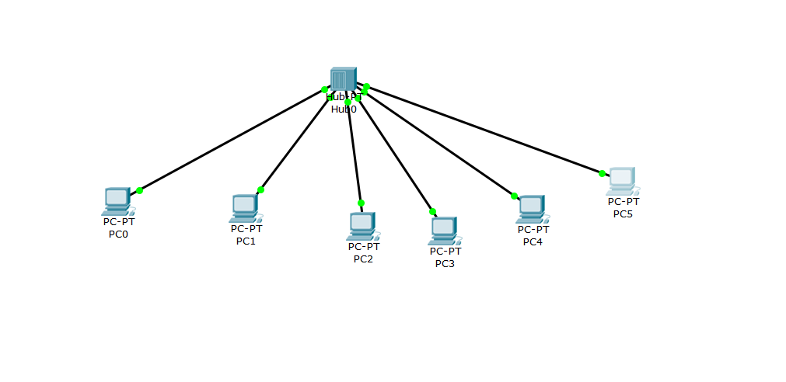

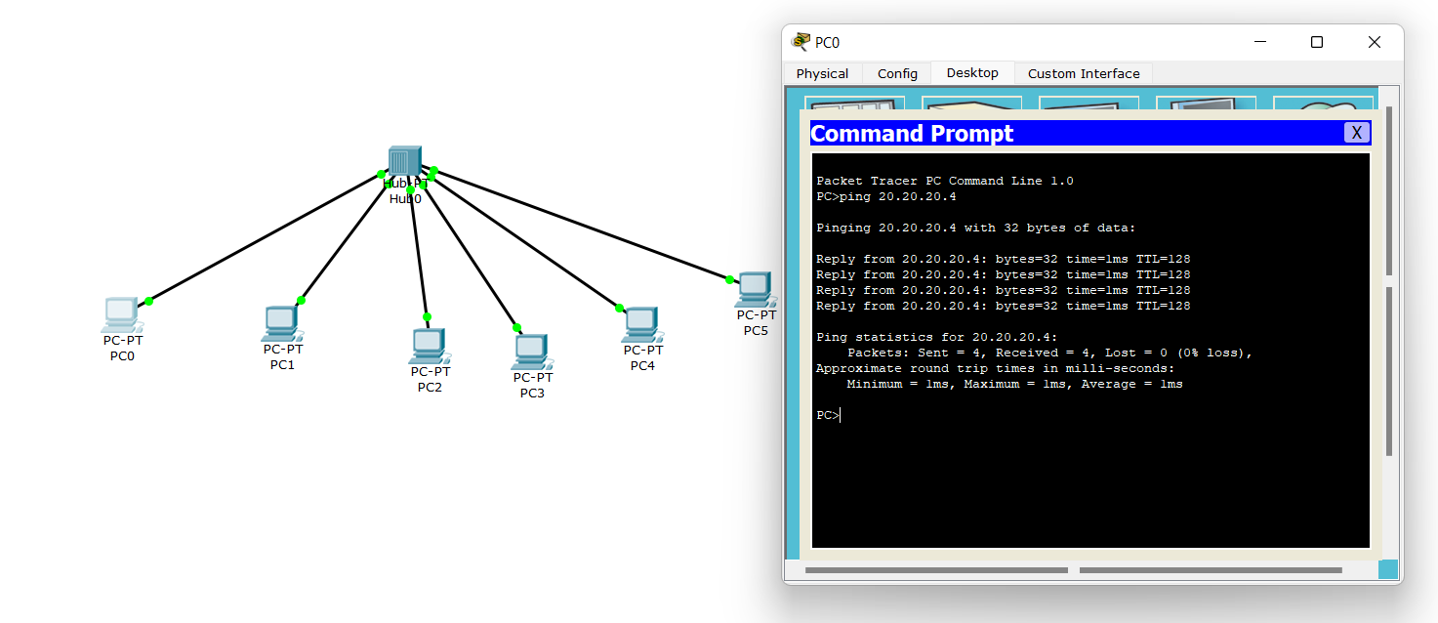  
  
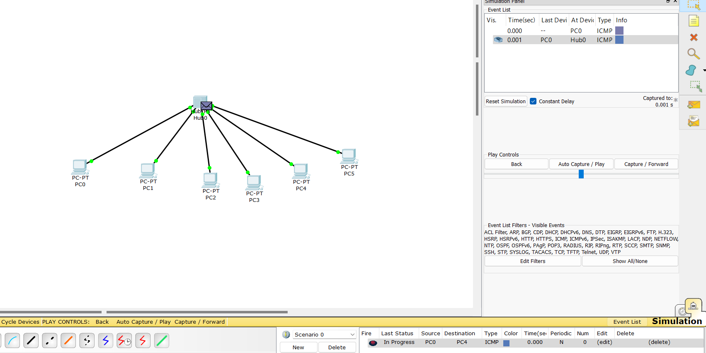  
  
  
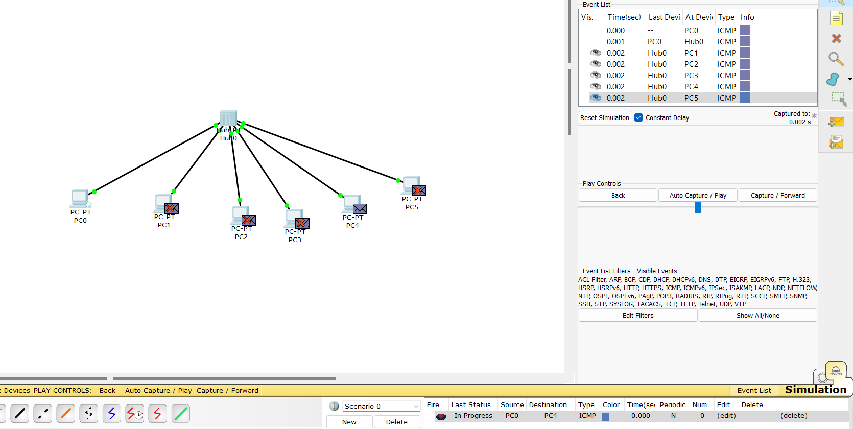  
  
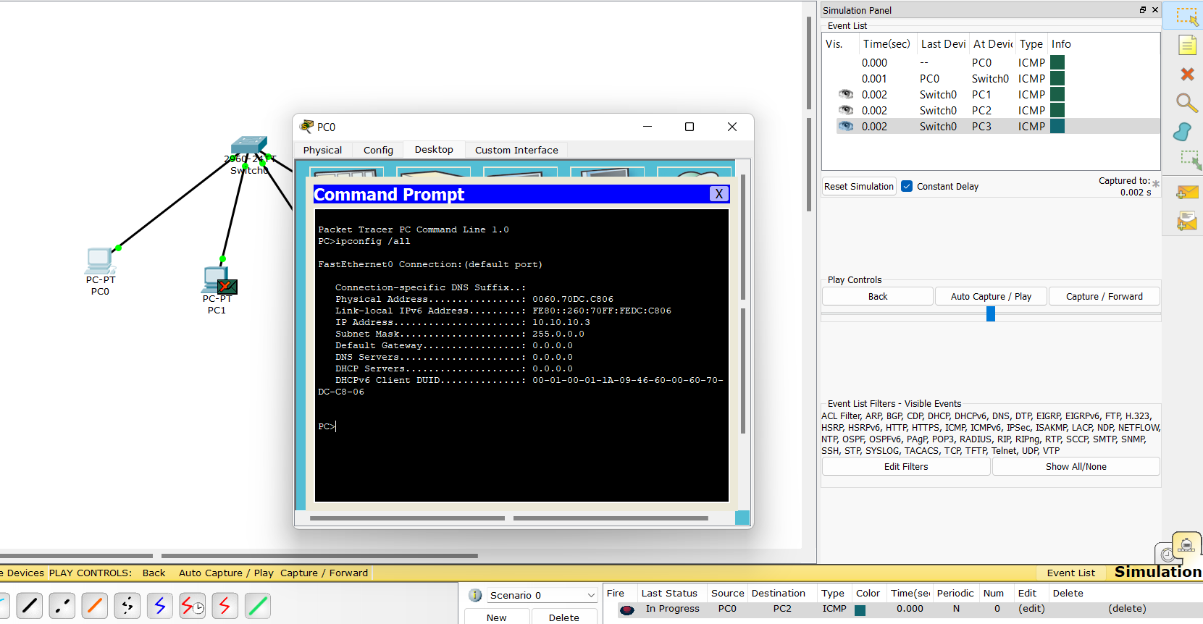  
  
  
  
  
Learning outcomes (What I have learnt):

1. Understood the concepts of hubs and switches in networking.

2. Learnt to connect devices with the help of hubs and switches and also gained knowledge about their hardware working.

3. One more implementation of packet tracer has been implemented.

Evaluation Grid (To be created as per the SOP and Assessment guidelines by the faculty):

|  |  |  |  |
| --- | --- | --- | --- |
| Sr. No. | Parameters | Marks Obtained | Maximum Marks |
| 1. |  |  |  |
| 2. |  |  |  |
| 3. |  |  |  |
|  |  |  |  |